Project Exodus Testing 2nd  Quarter Predictions

Introduction

The purpose of this analysis is to predict the number of applicants in the second quarter of 2017. Base of off previous data, there is a trend that shows what could possibly be the average for the second quarter. The predicted average will allow the Humans4Future Organization to determine how many applicants are expected to come and what their scores will be. In this summary, I will display the predictions for the second quarter, formulate trends based off all data, and draw conclusions on the data.

Methods

Javascript was used to calculate the sum of the scores for each month and the data provided from past results was used to determine the average score of each month by diving the sum with the applicants per a month. The charts were created in google sheets by importing the data created from the scripts. The predictions were created from Google’s forecast function which predicts the value based off the previous years and the month beforehand.

Results

These charts show the predicted values for the Scores and applicants for the second quarter of 2017. A trend can be formed based off the averages of all four years. For the applicants, there seems to be a general increase in the number of applicants per a year. There was a drop at 2015 at the beginning and end of the year but the number of applicants has increased steadily. For the scores, there has been a gradual decrease in average scores. There can be a possible correlation between the increase in applicants and the decrease in scores.

Keep first and last name separate, remove county and zip code, make gender not binary

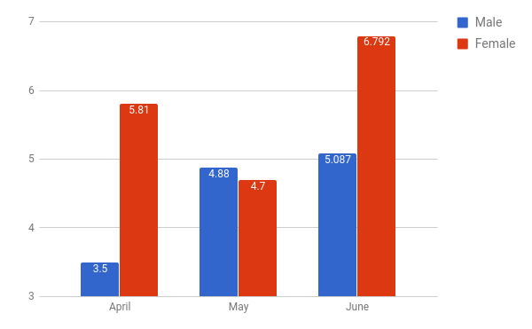

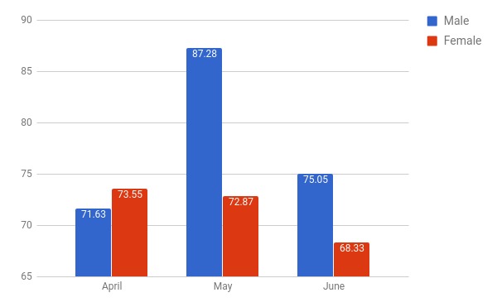

Conclusion

Based off the results from the prediction model. There can be a general prediction for 2018. Based off the trends of the four years. The number of applicants should go up while scores keep going down. This means that the average applicant won’t perform well on the test and will bring down the average as more people take part in the test. Suggestions on improving the data gathering for raw data would be to change gender classifications to male and female again while also separating last name and first name from the same field.